CS 255 System Design Document

UML Diagrams

UML Use Case Diagram
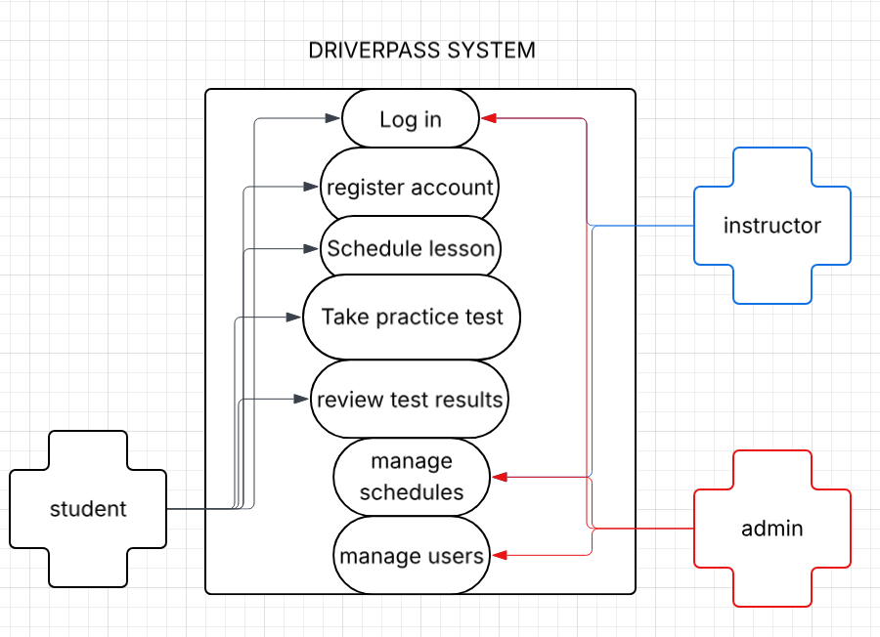

UML Activity Diagrams
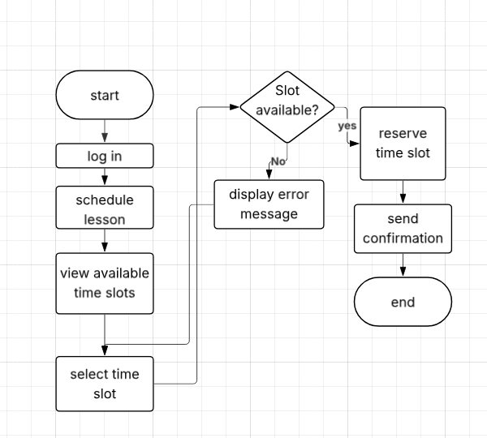

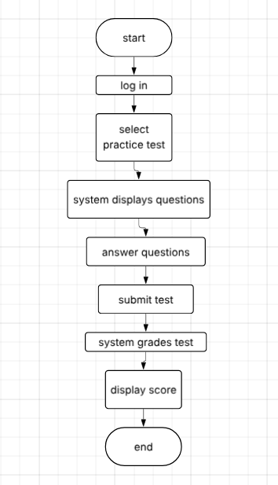

UML Sequence Diagram
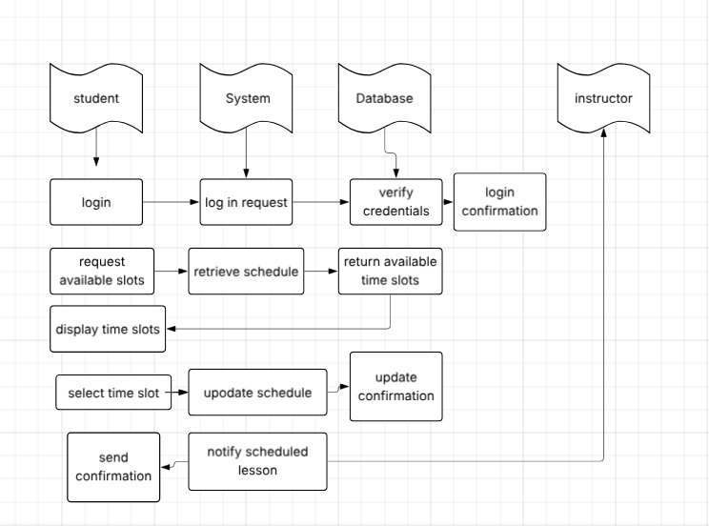

UML Class Diagram
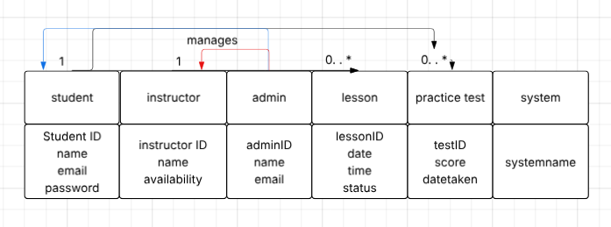

Technical Requirements
The DriverPass system is a web-based driving lesson and practice test management platform. To support the features shown in the diagrams, the system needs reliable hardware, software, tools, and infrastructure.
Hardware Requirements
- Cloud servers to host the application and database
- User devices such as smartphones, tablets, or laptops for students, instructors, and admins
- Network hardware that supports stable internet connectivity
- Backup storage hardware for data recovery
Software Requirements
- Web application interface for account management, scheduling, and testing
- Secure authentication system for login and user verification
- Database management system to store:
  - User information
  - Lesson schedules
  - Practice test questions, answers, and scores
- Automated grading logic for practice tests
- Notification system for lesson confirmations
Development Tools
- Programming frameworks for building the web system (such as backend and frontend frameworks)
- Database design and management tools
- Diagram and modeling tools for system documentation
- Security tools for encryption and access control
Infrastructure Requirements
- Cloud hosting service to ensure system availability
- Reliable internet connection for users and servers
- Data encryption for sensitive information like passwords and test results
- Regular data backup and recovery system
- Scalability support to handle multiple users at the same time

Summary
The DriverPass system requires cloud-based hosting, secure web application software, database storage, and reliable network infrastructure to support lesson scheduling, practice testing, and user management safely and efficiently.

